
Component Model
Calculate Target Point Meter Distance
Robotic Cognition System for Wheelchair
Unicamp

Table of Contents
1 Purpose of this Document 3
2 Component Design 4
2.1 Purpose 4
2.2 System Diagram 4
2.3 Component Input 4
2.4 Component Output 4
2.5 Component Processing 4
3 Component Execution 6
4 References 8

Document Information
Project Name: | Robotic Cognition System for Wheelchair
Prepared By: | Tarcísio Franco de Carvalho | Document Version No: | 1.0
Title: | Component Model – Calculate Target Point Meter Distance | Document Version Date: | 26/Apr/2021
Reviewed By: |  | Review Date:
Distribution List
From | Date | Email

Acronyms
Acronym | Description
ROS | Robot Operational System
UPD | Unevenness Point Descriptor

Document Version History
Version  Number | Version  Date | Revised By | Description | Filename

Purpose of this Document
Define how the related component works and its relation in the main system.

Component Design

Purpose
This component is responsible to calculate the distance in meters between the robot base and the target end point considering floor elevations as per environment point cloud classified by the UPD.

System Diagram

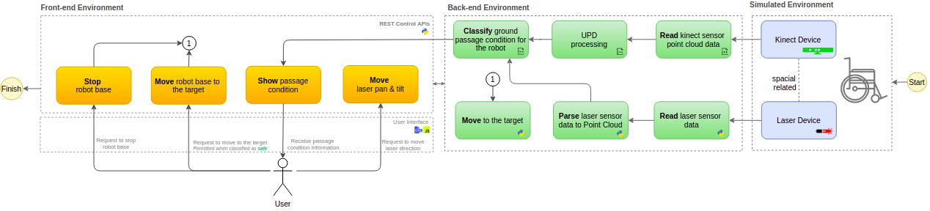

Component Input
This component expects the following input data:
- Current laser pan angle
- Current laser tilt angle

Component Output
This component will move the wheelchair robot base to the target point, where it is defined in meters in x and y axis direction from the current robot position. This target point is calculated based on laser pan and tilt angle information.

Component Processing
This component has relationship with the move_base/goal ROS node that is part of ROS navigation stack. The diagram below shows this relationship:

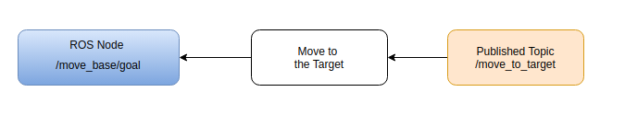

Below the main process flow for this component that runs in cycles:

- Convert the laser orientation data to X and Y axis point direction
- Set X and Y meters ahead to /move_base/goal node
- Monitor requested action completion and return it’s status

References

- Navigation
  - Article: https://www.researchgate.net/publication/335639360_Controlling_the_Distance_Between_the_Robot_and_Target_During_the_Tracking_Process
  - Nearest Neighbor Search: https://en.wikipedia.org/wiki/Nearest_neighbor_search
- Book - Learning Robotics using Python – Second Edition – By Lentin Joseph

